Figure 1:

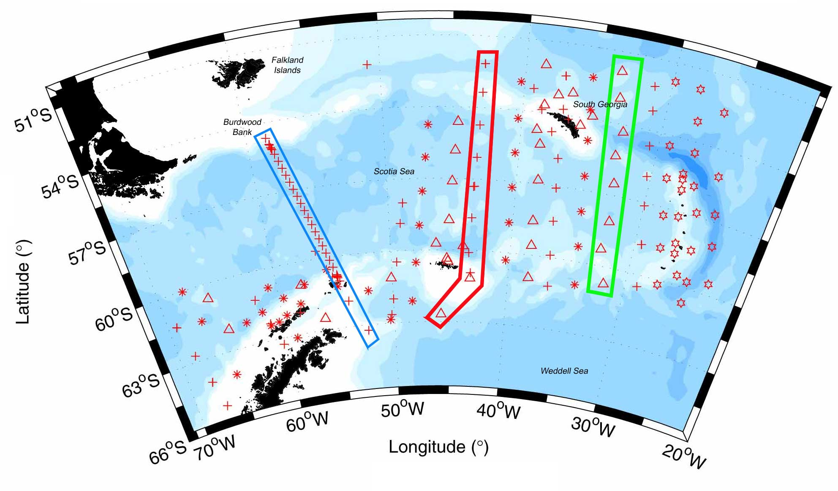

Figure 2

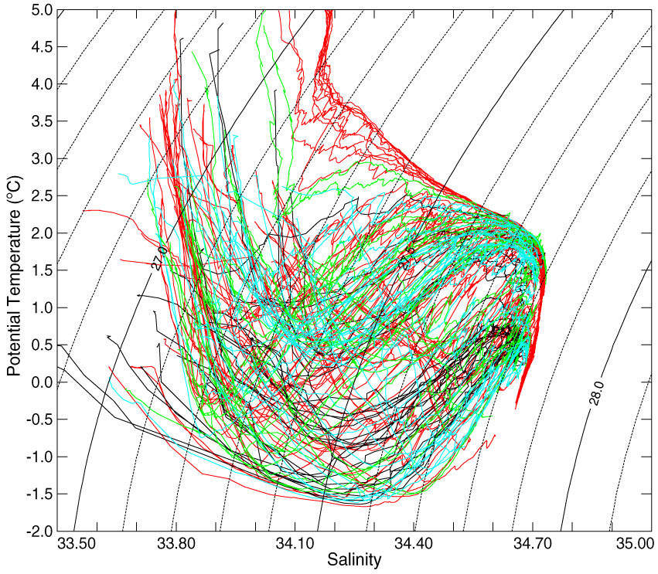

Figure 3

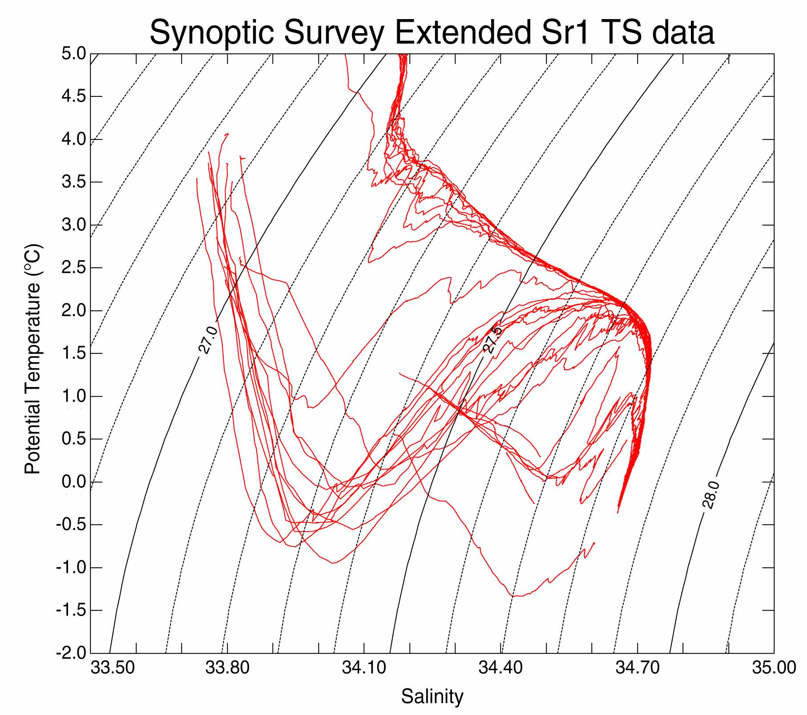
CDW
AASW
WSBW
WSDW
LCDW
UCDW
WW

