Figure 9

- Potential temperature (ºC).
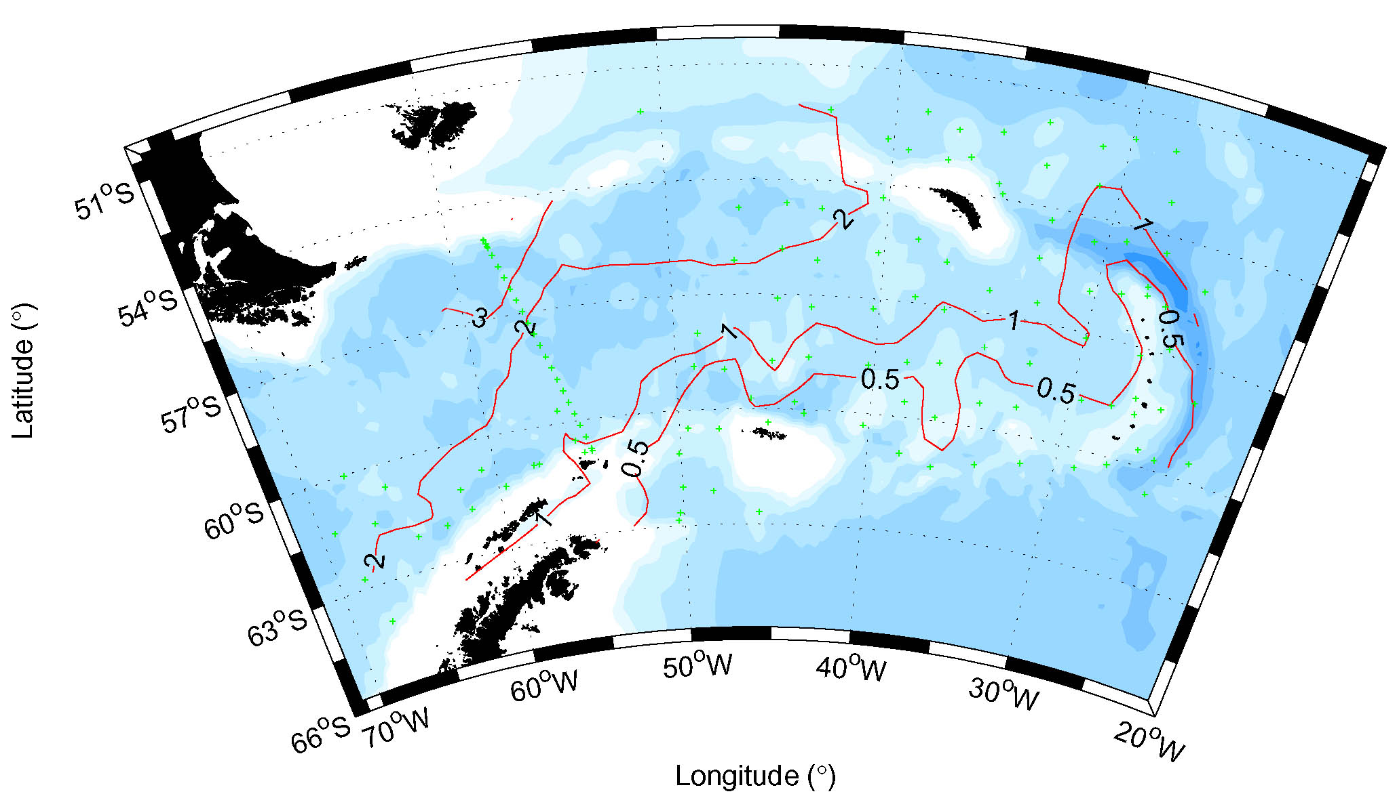

Figure 9

(B) Salinity.
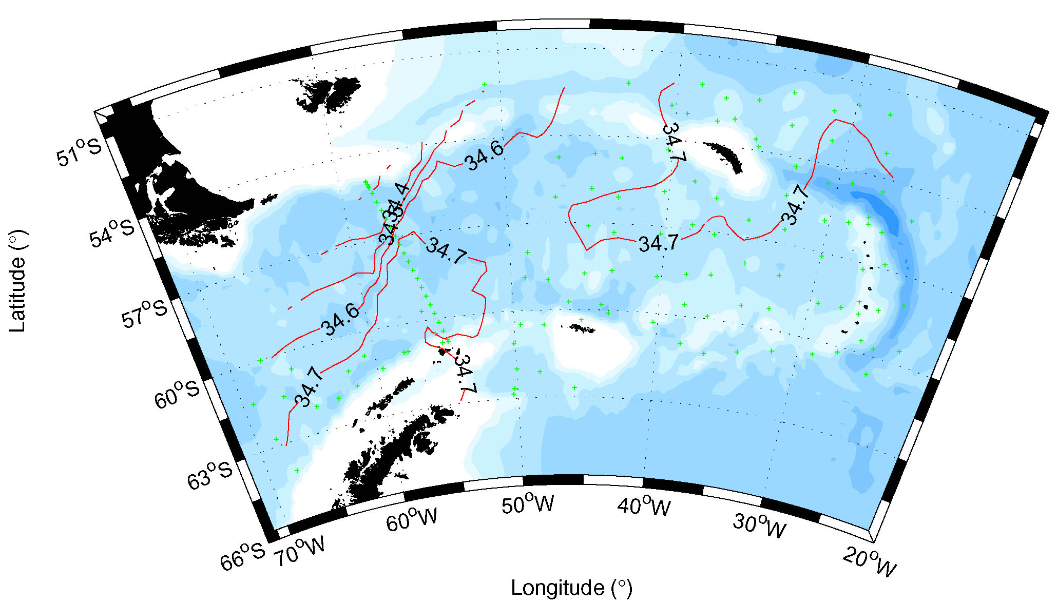

Figure 9

- Potential density σ_{o} (kg m⁻³).

