Figure 8

- Potential temperature (ºC).

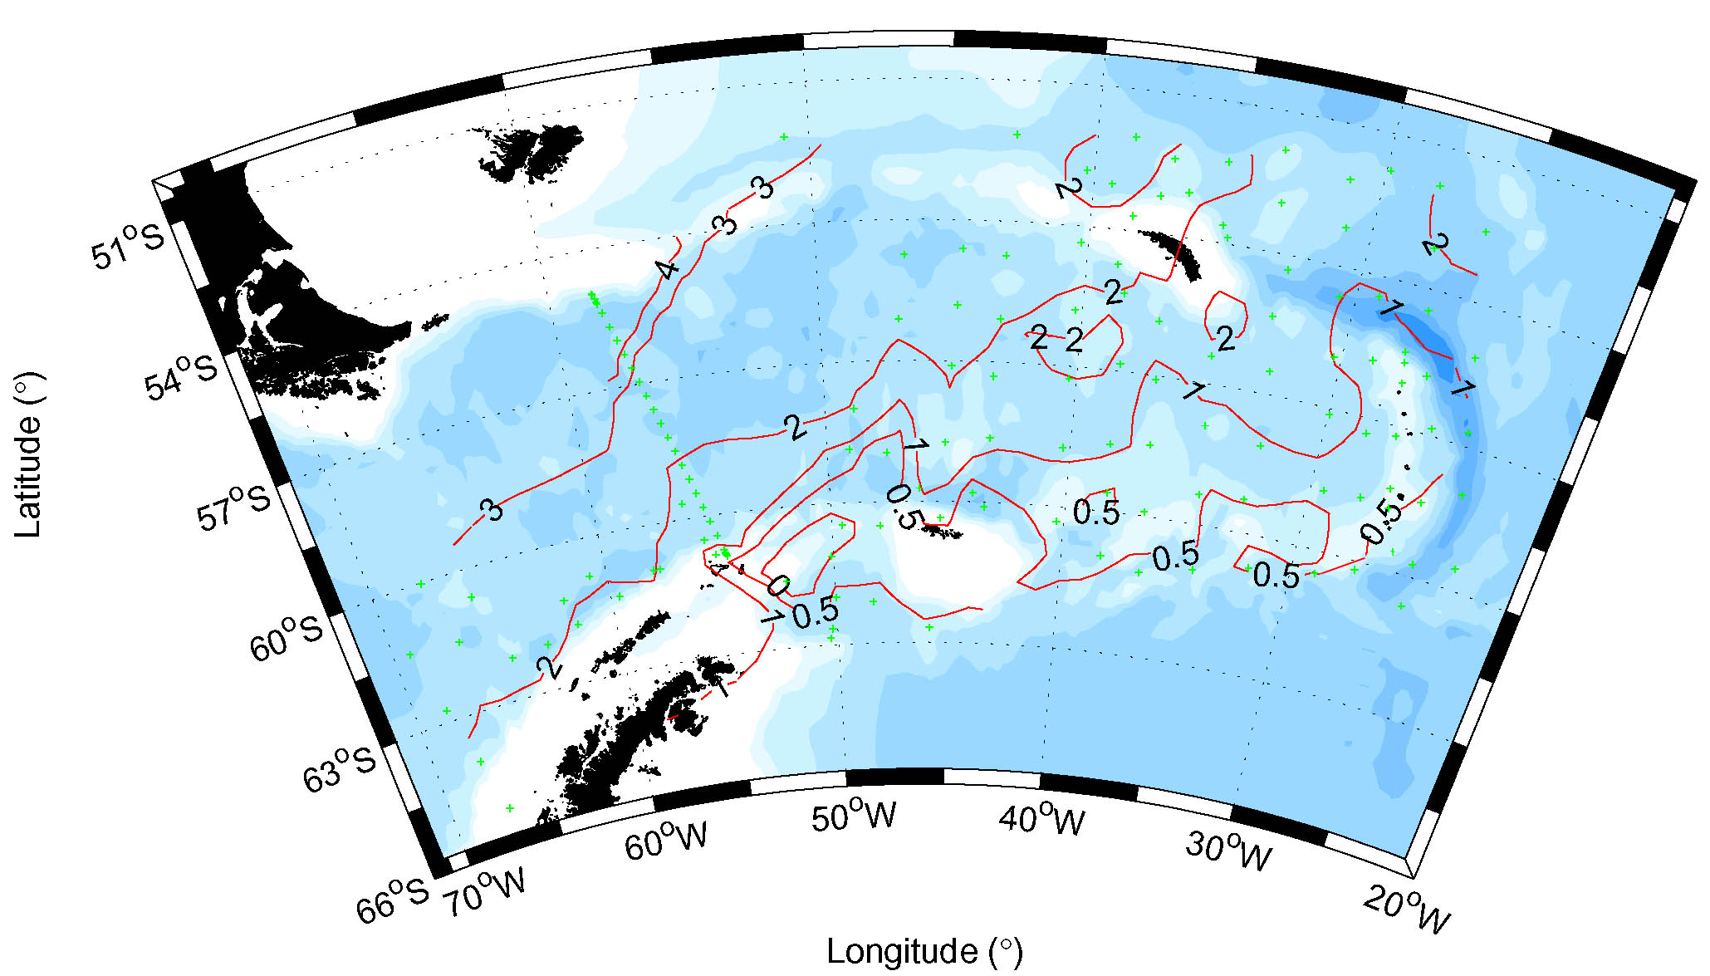

Figure 8

(B) Salinity (contours every 0.2)

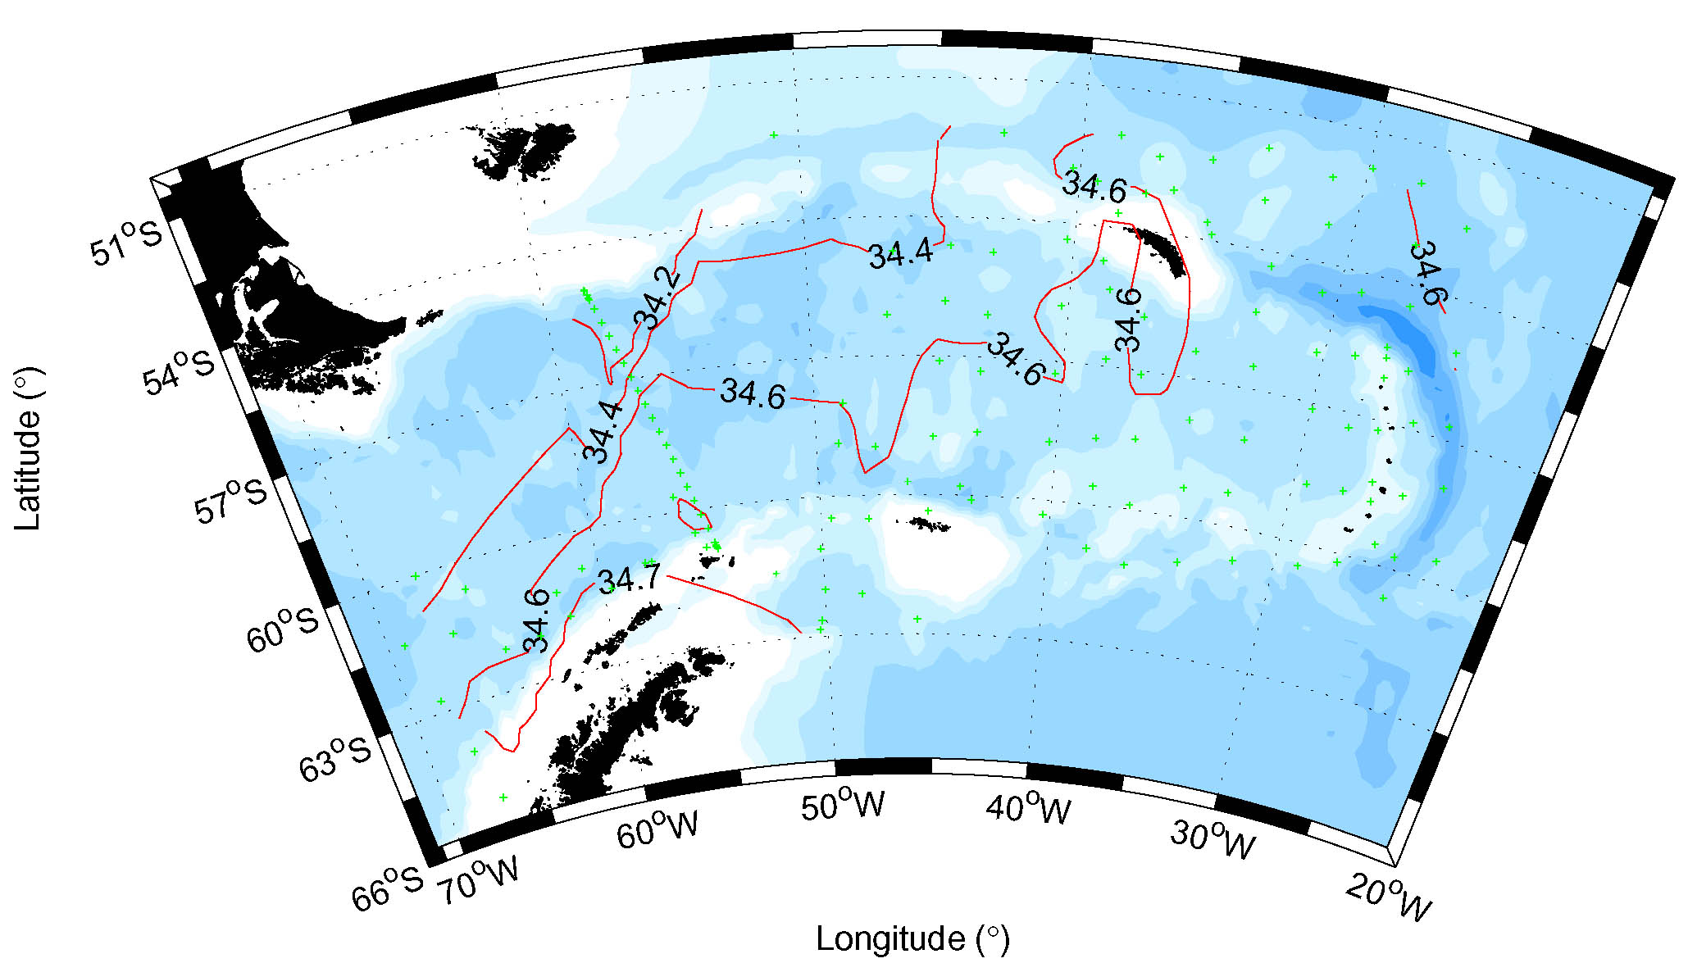

Figure 8

- Potential density σ_{o} (kg m⁻³). Contours every 0.1 kgm⁻³.

