Figure 7

- Potential temperature (ºC), contours every 1ºC.

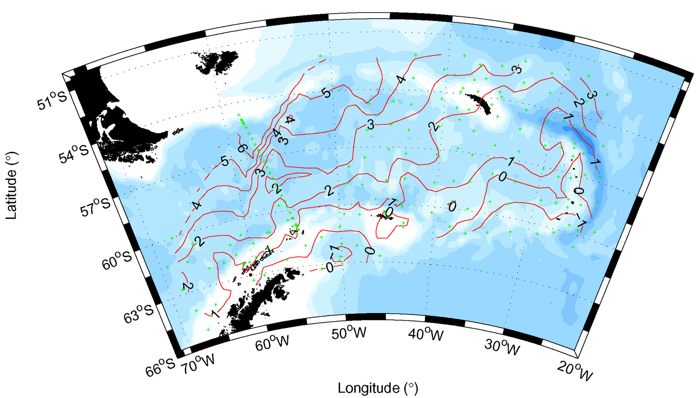

Figure 7

(B) Salinity (contours every 0.2)

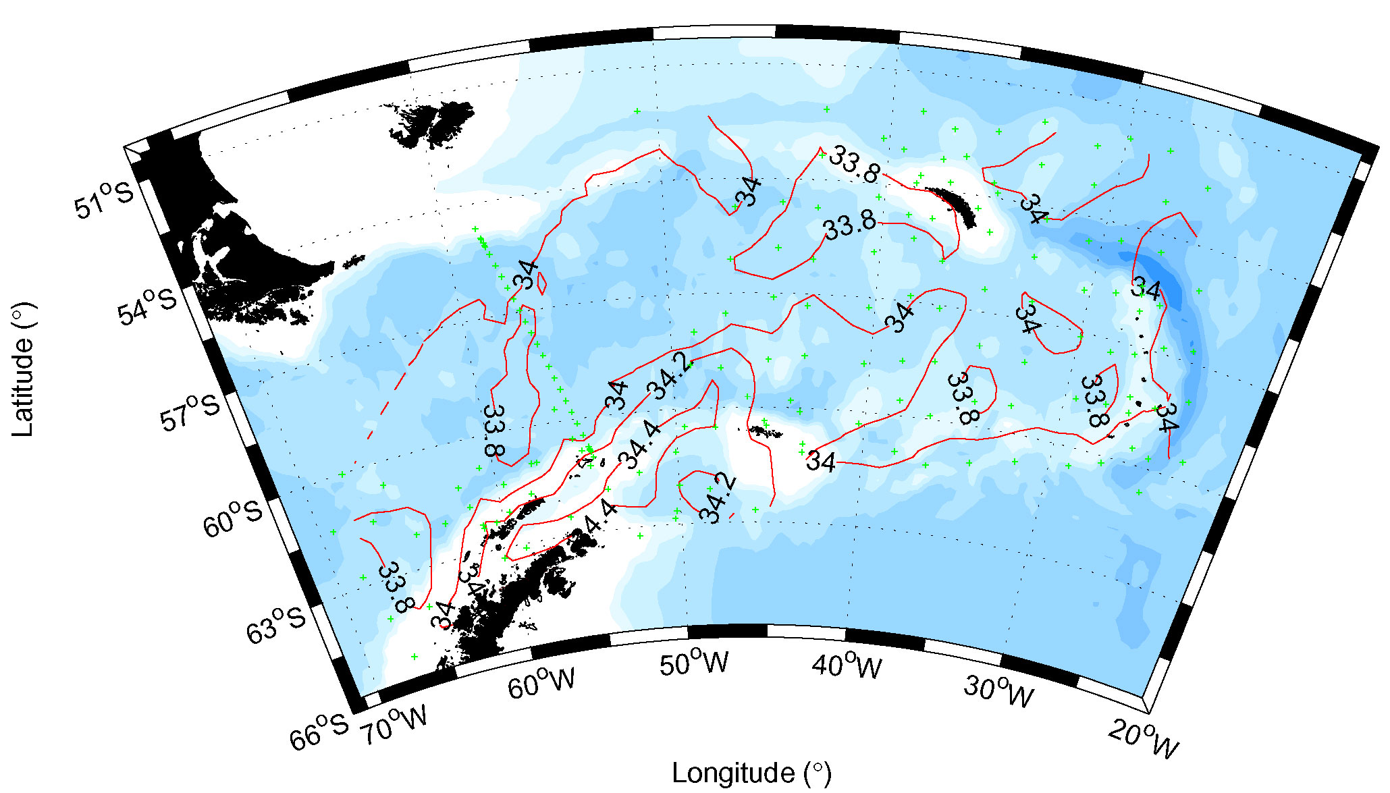

Figure 7

- Potential density σ_{o} (kg m⁻³). Contours every 0.1 kgm⁻³.

