Figure 6

(A) Potential temperature (ºC).
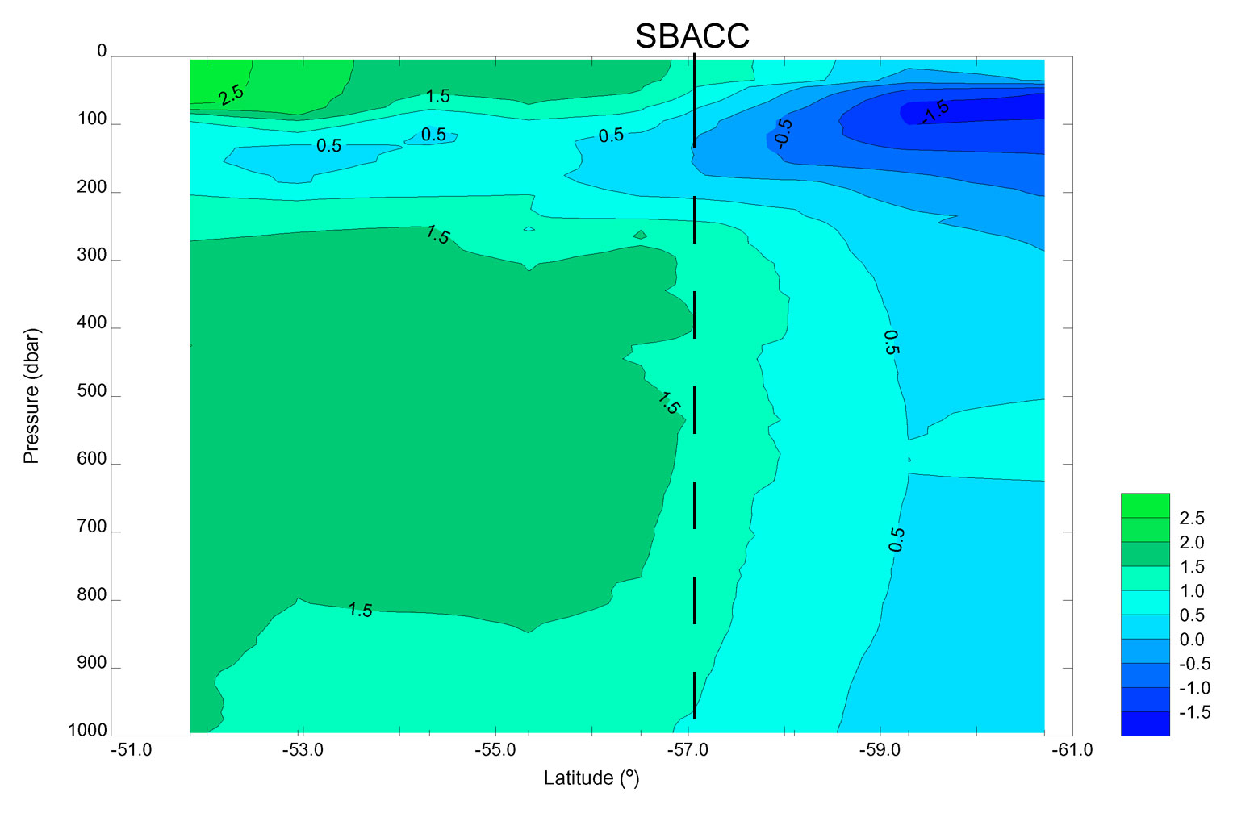

Figure 6

(B) Salinity.

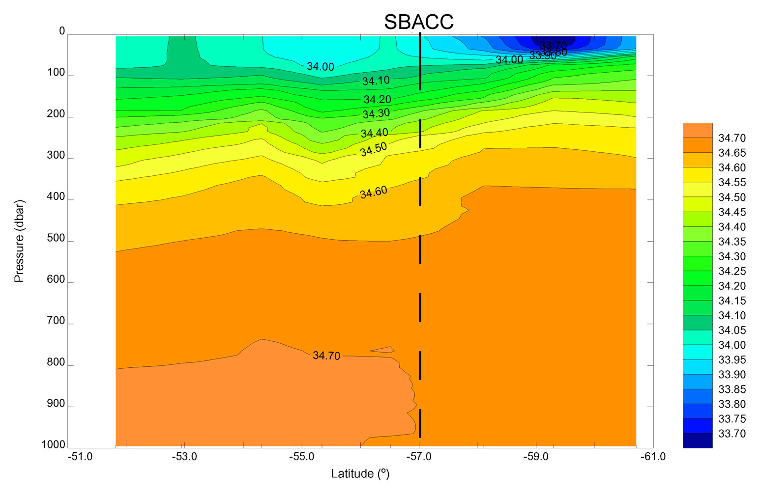

Figure 6

(C) Potential density σ_{o} (kg m⁻³).
