Figure 5

(A) Potential temperature (ºC).
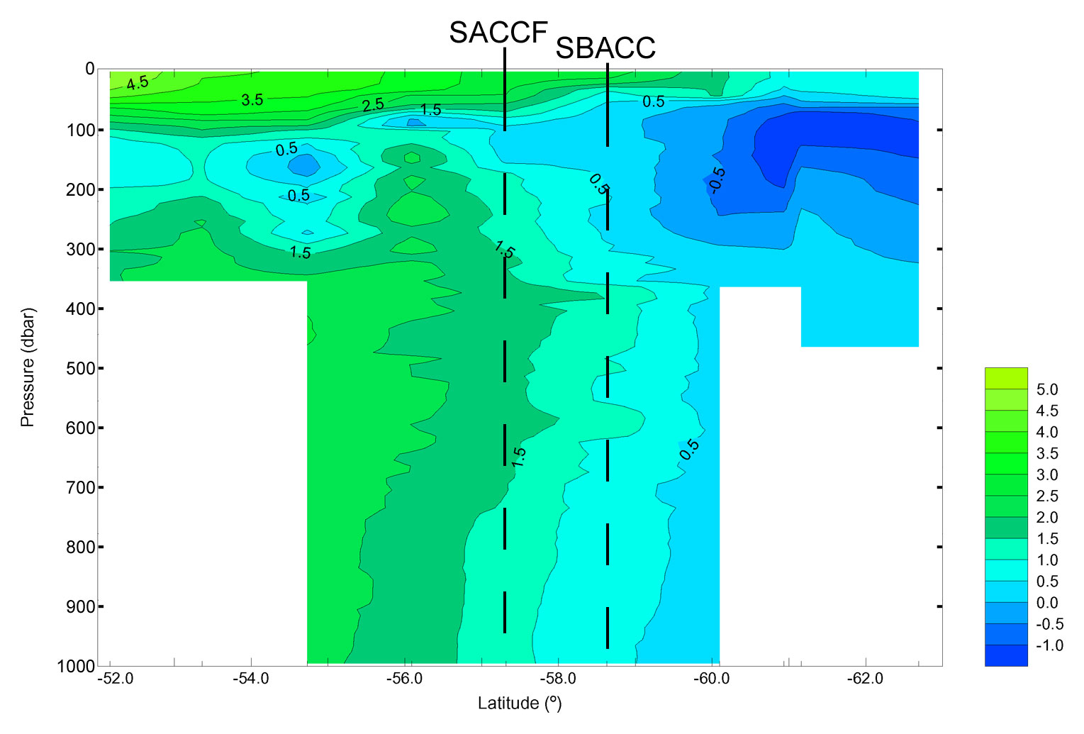

Figure 5

(B) Salinity.
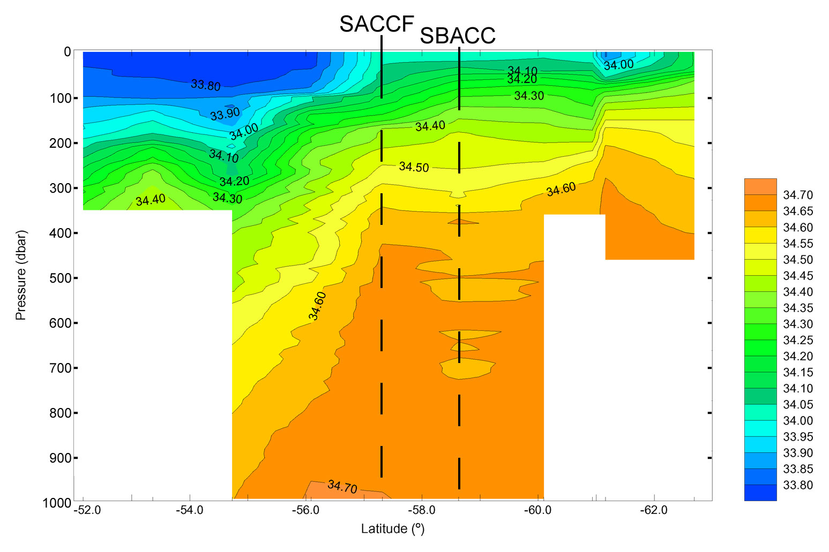

Figure 5

(C) Potential density σ_{o} (kg m⁻³).

