Figure 4

(A) Potential temperature (ºC).
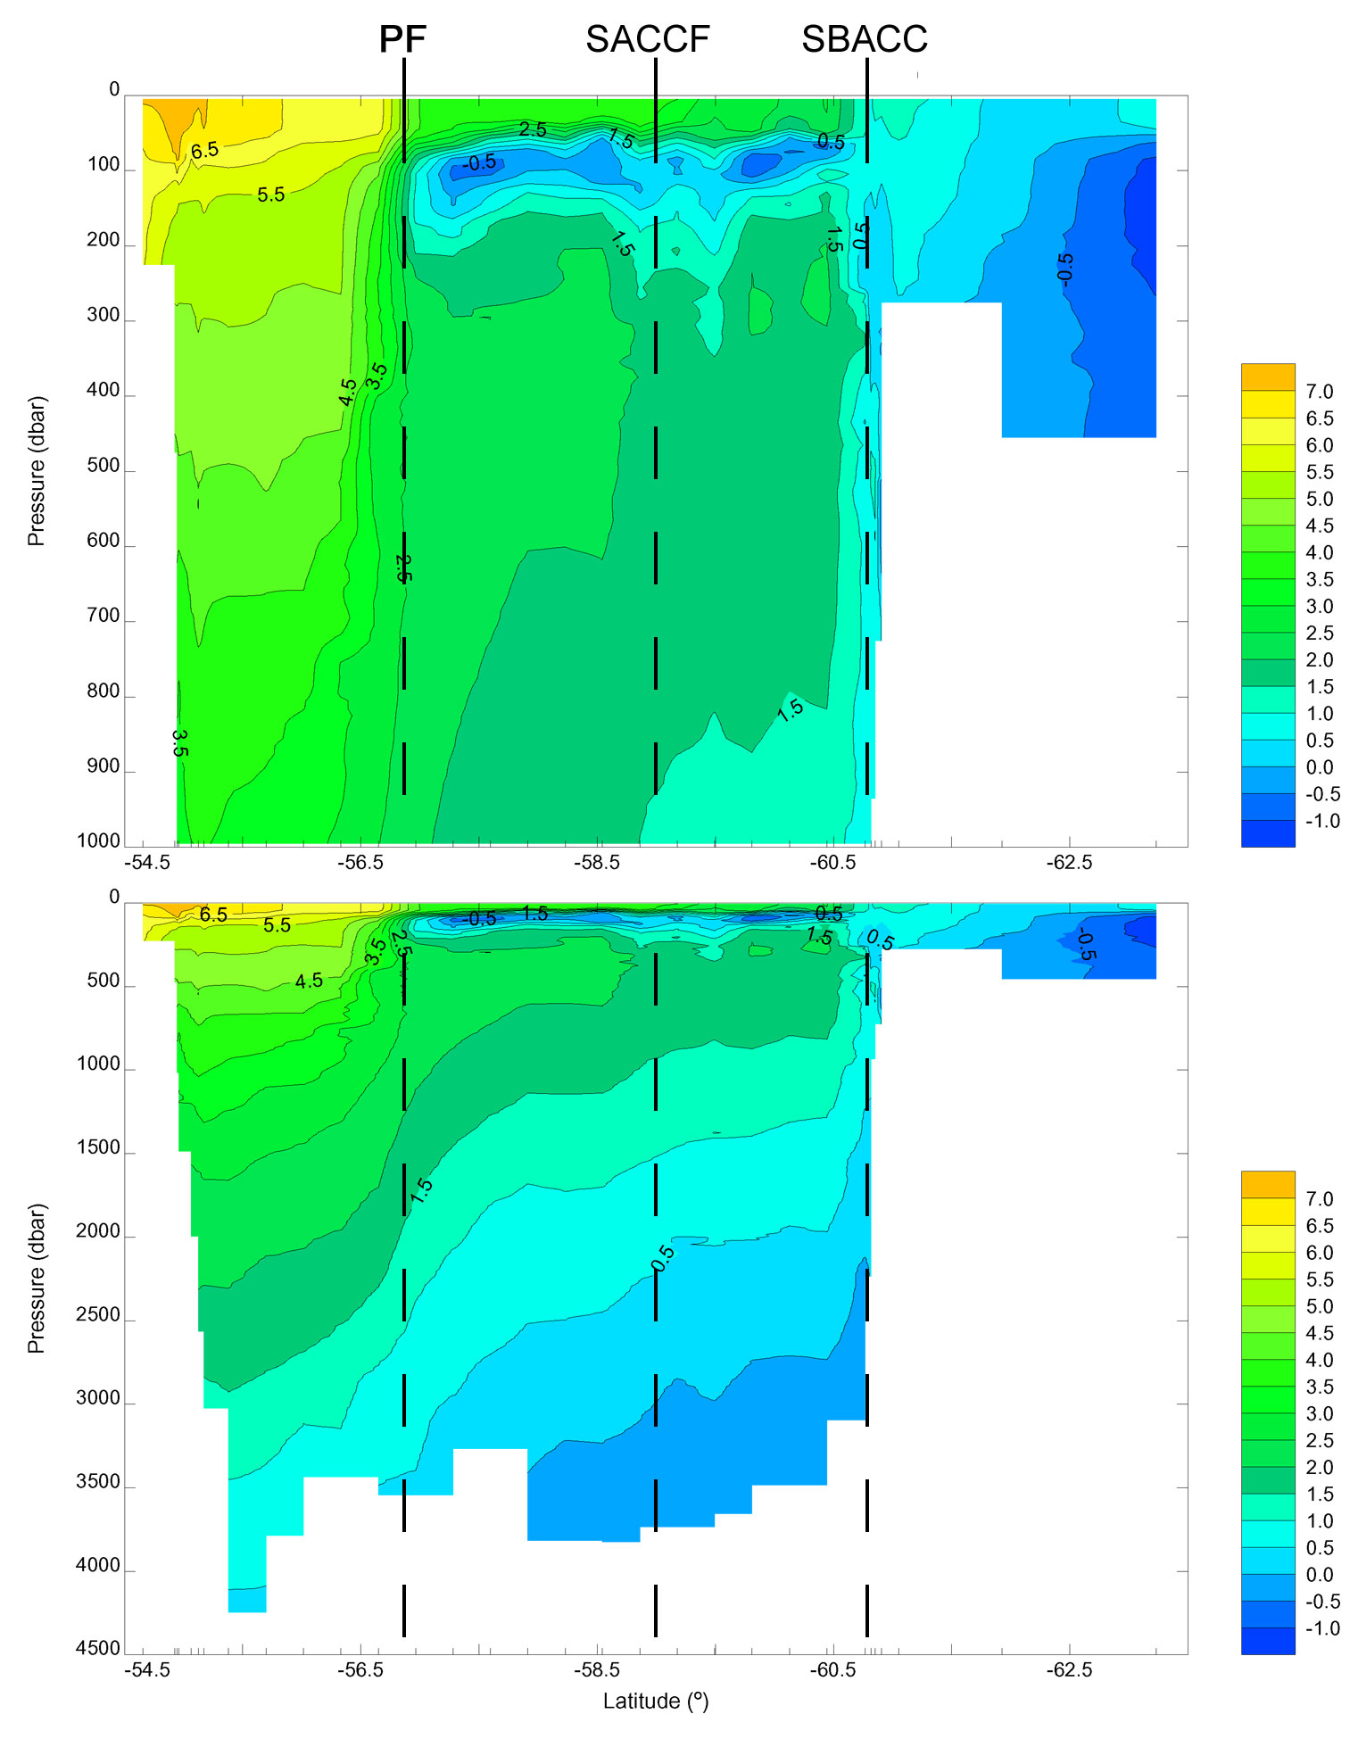

Figure 4

(B) Salinity.

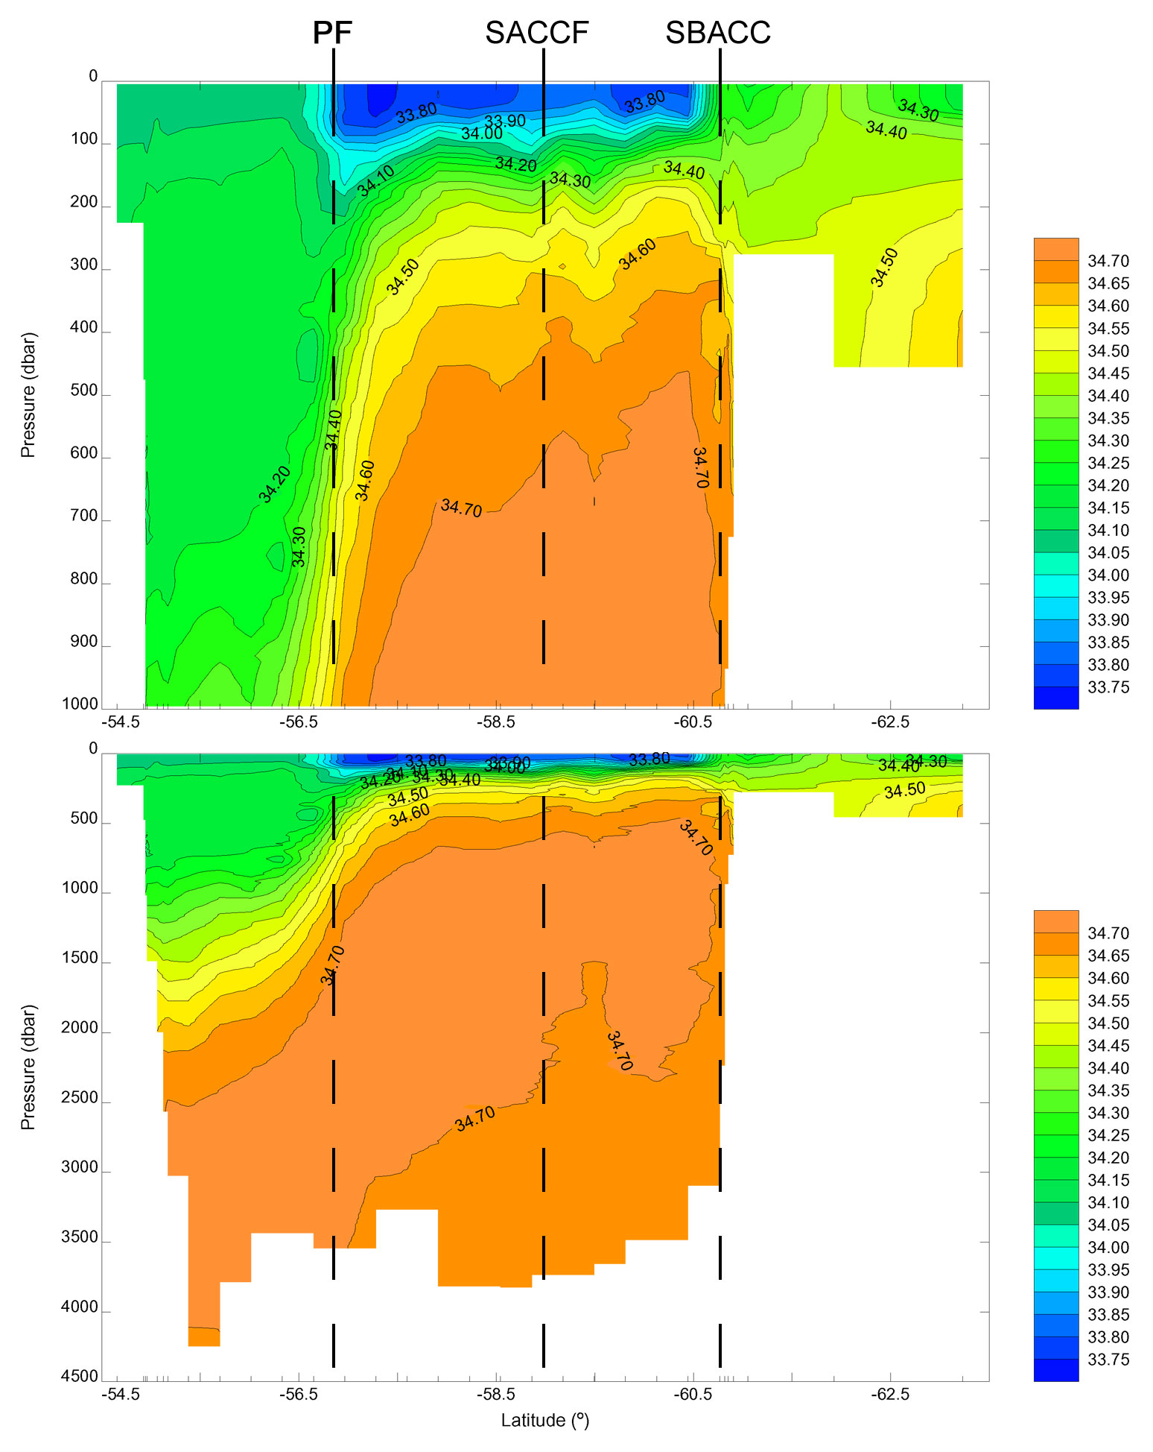

Figure 4

(C) Potential density σ_{o} (kg m⁻³).

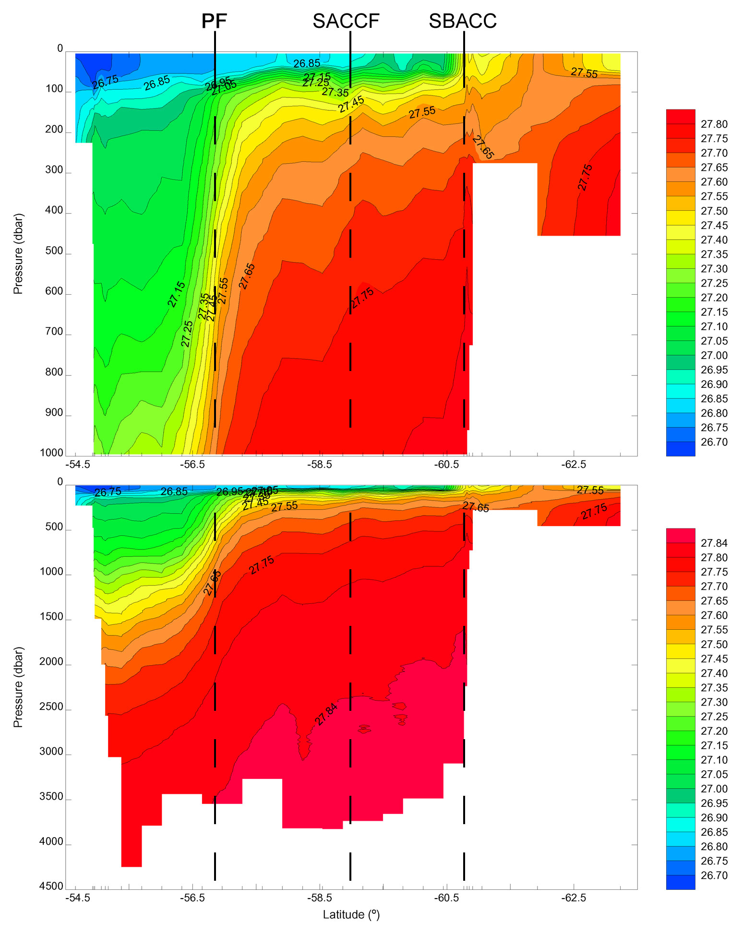

Figure 4

(D) Geostrophic velocity referenced to the sea floor (cms⁻¹).

